



**MORAY DISTRICT SCOUTS**

**Dear Parents, Scouts, Explorers, Network & Leaders.**

Some of you may already know about plans for our 2026 trip to Kandersteg International Scout Centre, (KISC) in Switzerland. The Event will take place in the ***summer of 2026,*** ***leaving the UK on the evening of Thursday 16th July and returning on Saturday 25th July,*** during the school summer holidays.

Enclosed in this pack, is one of the outlined programme ideas. The programme should give you an idea of what to expect, although it will not be finalised until next year. It may seem like the summer of 2026 is a long way off, but to organise a trip of this size takes a few years of planning. I also want to give you as much time as possible to be able to pay the camp fee, the balance is to be paid by monthly Standing Order.

There is a limit to spaces on this camp; this is largely to do with our accommodation, mode of transport and leaders. We will be traveling by coach, as we have in the past to Kandersteg.

Moray has almost 400 Scouts and 80 Explorer Scouts across eleven groups; our aim is to offer the opportunity to as many possible to attend. We have also a large team of adult leaders attending the trip to provide leadership, catering and activities. Accommodation in Switzerland will be in tents with an opportunity for an overnight in one of the Chalets.

If you have any specific questions about the trip, then drop me a message. We need to finalise our numbers as soon as possible. It is therefore important that you decide as soon as possible if you wish your son or daughter to attend. ***You need to complete an application form, and then arrange payment of the £100.01 deposit (which is non refundable). The total cost of the camp is £1025.00.*** After the deposit, it will leave 11 x equal payments of £84.09 a month, starting the 1st April 2025 and ending on the 1st of March 2026.

We need to receive deposits as soon as possible, as this will allow us to confirm your booking. We have a limit on numbers. KISC is very popular and we need people to pay their deposit asap to secure a place. **We only have 10 spaces remaining. Scouts must be at least 10.5 years old and within the Scout section to join us on this amazing trip.**

For those who have joined the trip there is a Kandersteg26 Facebook page you can join to keep up to date, <https://www.facebook.com/share/18RXLrDn6b/> this page is only for 18’s and over.

If you would like to sign up please email me for an application form and bank details, please let me know your child’s name, date of birth and which group they are in.

Note: I appreciate that this trip is a long way off and more money than a normal camp, so if you would like to discuss any aspect of the trip with me, please contact me ASAP. E-mail would be preferred, but any way that is easier for you.

Regards

# **Karen**

Karen Fotheringhame

**Moray Scout District - Kandersteg26 Lead**



**E-Mail:**  [1stdufftownscoutsgroup@gmail.com](mailto:1stdufftownscoutsgroup@gmail.com)



**Outline Programme** - *on these next two pages is* ***an example*** *of our itinerary for this 10 day trip, they are not necessarily what we will be doing on those actual days. The final programme will not be finalised until spring 2026 as we know the location, mountains and the various huts are part of the unique Kandersteg experience.*

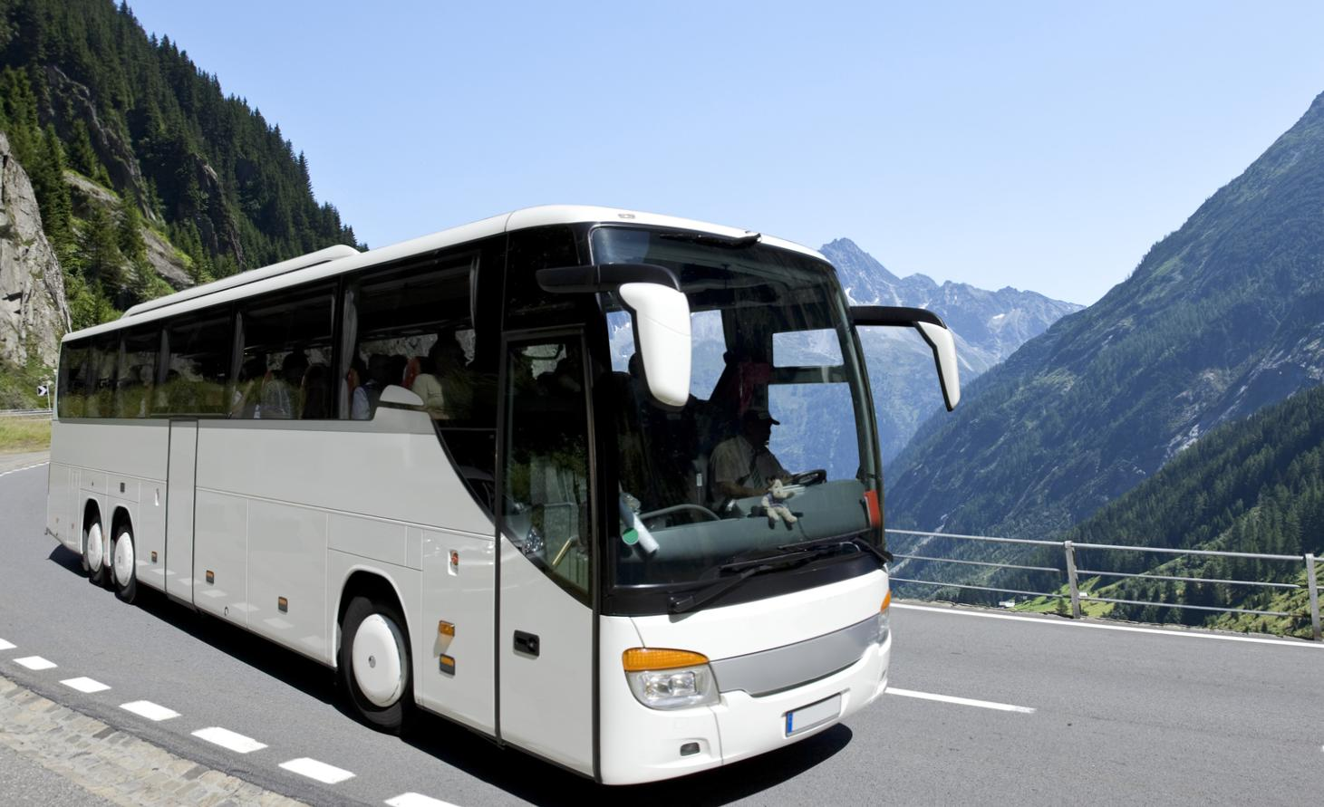**Thursday 16th July:** Meet at Elgin location TBC at approx 00:00 to depart the UK. Travel on luxury coach overnight (DVD, toilets, etc) and travel to Dover. A 18.00 crossing to Calais and then sleep as we travel through France and onto Switzerland.

**Friday 17th:** Arrive at KISC early morning, unpack sort tents and tent allocation, take some time to acclimatise to the 1200m above sea level height of our camp site and generally get a feel for the whole place. There will be over 2,000 Scouts and Guides on site from all around the World.

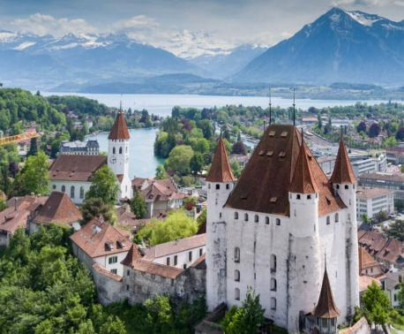**Saturday 18th:** Easy day of a walk into the village and then take the train to Thun, then a 15min walk to Thun Castle for a tour. Then we stop for lunch. After we head in the Thun village to explore, then back to the train station and return to Kandersteg for dinner. The evening will be spent taking part in the ‘light trail’ run by KISC.

**Sunday 19th:** The morning KISC holds there international Flag break and welcome, after Moray Scouts and Explorers will then set off on a Hike up to one of the Chalets, where they will get to see the sights and beauty of what Kandersteg holds. After lunch everyone will join in with KISC International Sports then go master there skills with Geocaching and KISC Compass Course. After dinner we will all join the traditional KISC International evening campfire.

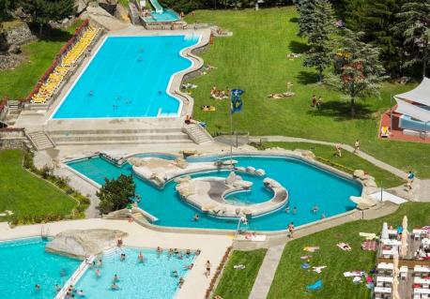**Monday 20th:** In the morning, we will head into Kandersteg to the train station, board the train to Brig, and then catch the bus to Brigerbad Water Park for some fun water activities and lunch. In the afternoon, we will head back on the bus to Brig train station and then head back to camp to relax and enjoy KISC’s International BBQ.

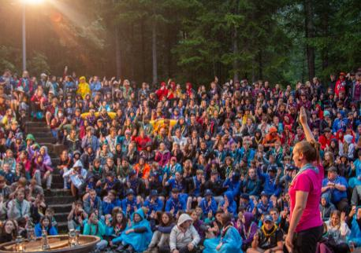

**Tuesday 21st:** The Scouts and Explorers will be enjoying the day at Frutigresort Adventure park, This unique high-ropes course, shaped like a tower, is the perfect activity for all adrenaline loving scouts. Located close to Kandersteg, this trip to the Frutigresort is the perfect way to fill a morning or an afternoon. Enjoy a panoramic view of the Swiss Mountains at the top of the course and then unwind with some Pool and Golf time. In the evening Scouts will be participating in the Kander Challenge run by KISC.

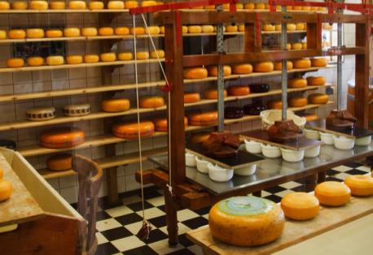**Wednesday 22nd July:** The day will be filled with all things Swiss. We will take a coach from KISC through the scenic Swiss countryside to the Cailler chocolate factory in Broc. Here, we will learn about the history of Swiss chocolate and how it is made before we get the chance to taste their signature recipes! From here, we will travel to the beautiful, picturesque village of Gruyère, where you will have some time to enjoy the surroundings and have lunch. We will then take a tour of the factory that produces the world-famous Gruyère cheese. In the end, we will have the chance to enjoy some cheese samples. We will then take a short walk and visit the Gruyère Village before heading back to KISC. Start the evening with the Rover Campfire Yarn, then enjoy a Swiss evening of yodelling and fondue. A day not to be missed!

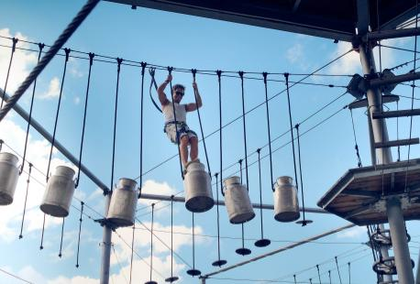**Thursday 23rd:** The Scouts are planning to spend a delightful day at KISC, where they will be participating in the Solar, Backwoods workshops, and Team-building Kander challenges, climbing, abseiling. Also there water activities such as rafting.

**Friday 24th:** Our final day on-site has arrived, and we are eager to make the most of it. We plan to complete our challenge badges and take some time to visit the local village shops for any last-minute gift purchases before our departure at 8 p.m.



**Saturday 25th:** Our arrival in Calais is scheduled for 08:00, and our departure via ferry is set for 10:00. We anticipate our return to the UK around 12:00, after which we will proceed with our journey to Scotland.

After driving through the night toward Moray, we aim to arrive back in Moray at approximately 23:59, on Saturday night, leaving the leaders some rest before returning to work on Monday, and allowing us to do some laundry.

